**PART 2**

**The acidic environment**

**2015**

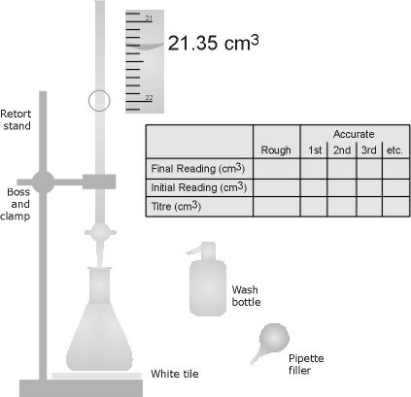

|  |  |  |
| --- | --- | --- |
| Prac Number | Prac name | Syllabus Ref |
| 6 | Extracting and  using a natural indicator.  Investigating colour changes of a range of indicators | perform a first-hand investigation to prepare and test a natural indicator  identify data and choose resources to gather information about the colour changes of a range of indicators |
| 7 | Determining the pH of some everyday solutions using a pH meter and an indicator | solve problems by applying information about the colour changes of indicators to classify some household substances as acidic, neutral or basic |
| 8 | Can chemical reactions go backwards |  |
| 9 | Determining the amount of carbon dioxide in soft drink | identify data, plan and perform a first-hand investigation to decarbonate soft drink and gather data to measure the mass changes involved and calculate the volume of gas released at 25˚C and 100kPa |
| 10 | Plan and perform a first-hand investigation to measure the pH of identical concentrations of strong and weak acids | plan and perform a first-hand investigation to measure the pH of identical concentrations of strong and weak acids |
| 11 | Determining the pH of salt solutions | choose equipment and perform a first-hand investigation to identify the pH of a range of salt solutions |
| 12 | Preparation of a primary standard solution and use it to measure the concentration of a solution of hydrochloric acid | perform a first-hand investigation and solve problems using titrations and including the preparation of standard solutions, and use available evidence to quantitatively and qualitatively describe the reaction between selected acids and bases |
| 13 | Use computer based technologies to measure the equivalence point for the titration of domestic acid and a strong base | perform a first-hand investigation to determine the concentration of a domestic acidic substance using computer-based technologies |
| 14 | Preparation of an ester | identify data, plan, select equipment and perform a first-hand investigation to prepare an ester using reflux |

**EXPERIMENT 6**

**EXTRACTING AND USING A NATURAL INDICATOR**

**INVESTIGATING COLOUR CHANGES OF A RANGE OF INDICATORS**

**INTRODUCTION**

Acid–base indicators are substances that in solution change colour depending on whether the solution is acidic or alkaline. Various plants, including red cabbage, contain certain dyes that can act as acid–base indicators. The actual range of acidity or alkalinity over which indicators change colour varies from one indicator to another.

An indicator is a substance that in solution changes colour depending on whether the solution is acidic or alkaline. The colour change and the range over which the change occurs varies from one indicator to another. Some indicators have one colour in acid solution and a different colour in alkaline solution, while other indicators change colour as the acidity or alkalinity varies.

**Aim**

1. To prepare an indicator solution from red cabbage
2. To prepare acidic and alkaline solutions of different concentrations and use these to investigate the colour changes in a range of indicators.

**EQUIPMENT**

* 4 Spotting plates

**CHEMICALS**

2–3 large red cabbage leaves (shredded)

0.1 M mol/L NaOH (sodium hydroxide)

0.1M mol/L HCl (hydrochloric acid)

pH solutions 4-9

Dropper bottles of methyl orange, bromothymol blue, phenolphthalein, litmus and

universal indicator

**RISK ASSESSMENT**

|  |  |  |
| --- | --- | --- |
| What is the Risk | Why is it a Risk? | How will you minimize the risk? |
|  |  |  |
|  |  |  |
|  |  |  |
|  |  |  |

**METHOD**

1. **EXTRACTION OF INDICATOR FROM RED CABBAGE**

**1** Place shredded cabbage in 250 mL beaker and just cover with distilled water (about 50 mL). Slowly boil the cabbage leaves until the water turns a dark reddish-purple and the leaves lose most of their colour.

**2** Allow to cool and pour the liquid off into a clean 250 mL beaker. This is the natural indicator. **Note:** If the colour of the solution is pale, further boiling may be necessary to concentrate the solution.

**b. TESTING OF INDICATORS**

**1.**  Place 2 drops of 0.1 M NaOH, 0.1M HCl and of each of the pH solutions onto separate spots in the spot testing plate. Add a few drops of natural indicator from the red cabbage to each sample until a definite colour is observed. Record the colour of the indicator in your results table.

**2.** Repeat step 1 with the other indicators listed in the table and record your results. Classify the substances as acidic, basic or neutral.

**3** *Optional*: Test each of the solutions with universal indicator to check your classification. You will learn about pH later, for the moment, if pH is less than 6 the solution is acidic, if it is between 6 and 8 it is neutral, and if it is greater than 8 the solution is basic (alkaline).

**RESULTS**

Complete the table

|  |  |  |  |  |  |  |  |  |
| --- | --- | --- | --- | --- | --- | --- | --- | --- |
| **Solution /pH** | **0.1M HCl** | **4** | **5** | **6** | **7** | **8** | **9** | **0.1M NaOH** |
| **Acidic or  alkaline** |  |  |  |  |  |  |  |  |
| **Indicator 1 RED CABBAGE** |  |  |  |  |  |  |  |  |
| **Indicator 2 BROMOTHYMOL BLUE** |  |  |  |  |  |  |  |  |
| **Indicator 3 methyl orange** |  |  |  |  |  |  |  |  |
| **Indicator 4**  **litmus** |  |  |  |  |  |  |  |  |
| **Indicator 5 phenolPHthalein** |  |  |  |  |  |  |  |  |
| **INDICATOR 6**  **UNIVERSAL INDICATOR (which is a mixture of other indicators)** |  |  |  |  |  |  |  |  |

**QUESTIONS**

**1** Which of the tested indicators would be most useful in distinguishing between:

**a** acidic and neutral solutions?

**b** alkaline and neutral solutions?

**2** Identify two indicators which, together, give the most information over a range of solutions of different concentrations. Justify your choice.

1. Universal indicator is a mixture of a number of different indicators. Suggest why this is useful.
2. What indicators are used to make up universal indicator?

**EXPERIMENT 7**

**DETERMINING THE pH OF SOME EVERYDAY SOLUTIONS USING A pH METER AND AN INDICATOR**

**INTRODUCTION**

Many of the foods, drinks and materials we use in everyday life can be classified as acidic, basic or neutral. Indicators can be used to determine this and give an estimate of the pH of a solution by their colour change. There are meters that measure pH directly. A big advantage of these is that in measuring the pH of a solution it does not alter the pH of the solution in any way. pH meters give fairly accurate pH readings.

**Aim**

To measure the pH of a range of various common substances using a pH meter and universal indicator.

**EQUIPMENT**

pH meter

Small beakers

**INSTRUCTIONS FOR pH METER**

**Handle the pH meter carefully the glass electrode is very fragile. The electrode needs to be kept wet at all times but do not let it soak in distilled water – only the soaking solution.**

1. Remove pH meter from the soaking solution (pH7 buffer) and rinse the electrode with distilled water from a wash bottle. Have a beaker available to collect the rinsing water.
2. Turn the meter on and place the electrode in the sample
3. Take the reading and rinse the pH electrode again collecting the water in the beaker.
4. Take as many readings as required rinsing the electrode between each.
5. Do not place the pH meter flat on the bench. It can be put back into the soaking solution at any time – just remember to rinse the tip before use.

**CHEMICALS**

Universal indicator

Approx 10 mL of a solution of each of:

0.1 mol/L NaOH (sodium hydroxide)

0.1 mol/L HCl (hydrochloric acid)

(These are for comparison-they are not household chemicals )

White vinegar

Lemonade

Lemon juice

Salt water

Bicarbonate of soda

Washing powder

Dishwashing liquid

Dropper bottle universal indicator

Distilled water

OTHER SAMPLES OF HOUSEHOLD SUBSTANCES AS AVAILABLE.

**RISK ASSESSMENT**

|  |  |  |
| --- | --- | --- |
| What is the Risk | Why is it a Risk? | How will you minimise the risk? |
|  |  |  |
|  |  |  |
|  |  |  |
|  |  |  |
|  |  |  |

**METHOD**

1. Check pH meter is correctly calibrated and review instructions for use. Ensure pH meter is properly handled and rinsed before testing each substance.

**2.** Take a small sample of 10 different substances. Samples need to be diluted with distilled water

**3.** Place a small amount of solution to be tested in a small beaker (about 3 cm depth). Insert the pH meter electrode and record the pH.

**4.** Measure the pH by adding a couple of drops of universal indicator to the beaker and record the results.

**5.** Repeat with all samples being sure to rinse pH meter electrode and beaker with distilled water between samples.

**Results**

|  |  |  |  |
| --- | --- | --- | --- |
| **Sample** | **pH meter reading** | **Universal indicator colour and pH** | **Acidic/basic/neutral** |
|  |  |  |  |
|  |  |  |  |
|  |  |  |  |
|  |  |  |  |
|  |  |  |  |
|  |  |  |  |
|  |  |  |  |
|  |  |  |  |
|  |  |  |  |

**QUESTIONS**

**1** On the basis of the results classify the substances as acidic, basic or neutral.

**2** What generalization can be made about substances used for similar purposes, for example, cleaning products?

**3** Compare the results obtained from the pH meter with those obtained from the universal indicator. Discuss any differences.

**EXPERIMENT 8**

**CAN CHEMICAL REACTIONS GO BACKWARDS**

This experiment is about reversible reactions. The introduction contains valuable theory about that experiment so read it carefully.

**INTRODUCTION**

If you mixed a solution of sodium carbonate with a solution of calcium chloride you would expect to see a precipitate of calcium carbonate as calcium carbonate is insoluble in water. This precipitation reaction can be represented by the following equation:

Na2CO3 + CaCl2 2NaCl + CaCO3(s)

Claude Berthollet was a French chemist who was a contemporary of Antoine Lavoisier. Berthollet, however, unlike Lavoisier, avoided being guillotined during the Reign of Terror in the French Revolution and continued practising chemistry through the revolution and into the dictatorship of Napoleon Bonaparte. Berthollet taught chemistry to Napoleon and accompanied him as scientific adviser on an ill-fated expedition to Egypt in 1798.

While he was in Egypt Berthollet observed a lake of salt water with a limestone bottom and a crust of sodium carbonate crystallising at its edges. To a chemist, this was an astonishing sight, because it meant that the dissolved limestone was reacting with the salt in the water to produce sodium carbonate. This reaction can be represented by the following equation:

2NaCl + CaCO3 Na2CO3(s) + CaCl2

This is the **opposite reaction** from that which normally spontaneously occurs.

Berthollet suspected that the reaction had been reversed by the very large concentration of sodium chloride in the water of the lake. Berthollet concluded, after further observations (after he had escaped back to France with Napoleon!) that many reactions were reversible, and that the concentrations of reactants and products affect which direction a particular reaction will proceed.

In this investigation you will observe some reactions taking place (by noting precipitation, dissolving and colour changes). You will then reverse the reactions which have taken place by changing the concentration of one of the reactants involved.

**EQUIPMENT**

Test tubes

Test tube rack

**CHEMICALS**

* 2mL of 0.25mol/L copper(II) sulfate solution
* 1mol/L ammonium hydroxide in a dropper bottle (remember to open the windows)
* 1mol/L sulfuric acid in a dropper bottle

**RISK ASSESSMENT**

|  |  |  |
| --- | --- | --- |
| What is the Risk | Why is it a Risk? | How will you minimise the risk? |
|  |  |  |
|  |  |  |
|  |  |  |

**Aim**

To observe a reversible chemical reaction.

**METHOD**

* Put about 2mL of the copper(II) sulfate solution into the large test tube. Look at it carefully and note its appearance in your practical book.
* Add the ammonia solution to the copper(II) sulfate solution drop by drop. Record your observations.
* Keep adding the ammonia solution until another change has occurred. The mixture should now be a deep royal blue and not contain any of the pale blue precipitate.
* Add 1M sulfuric acid to the solution drop by drop. Observe what happens,
* Now add ammonia solution again drop by drop. Observe what happens

**OBSERVATIONS**

*When the ammonia solution is first added to the copper(II) sulfate solution a precipitate forms. This is copper(II) hydroxide. It forms because the addition of ammonia to the solution leads to the release of hydroxide ions into the mixture which then precipitate with the copper ions. Copper(II) hydroxide is insoluble.*

*As more ammonia is added, all of the copper ions are precipitated and the concentration of ammonia in the solution builds up. As it does so, the ammonia starts to react with the copper(II) ions in the copper(II) hydroxide to form the royal blue tetrammine copper(II) ion in solution. As this happens, the copper(II) hydroxide dissolves again.)*

*If we now add some sulfuric acid to the solution, this effectively reduces the concentration of ammonia in the system (it converts the ammonia to ammonium ions). As the ammonia concentration falls, will this result in the reactions you just observed being reversed?*

**EXPERIMENT 9**

**DETERMINING THE AMOUNT OF CARBON DIOXIDE IN SOFT DRINK**

**Introduction**

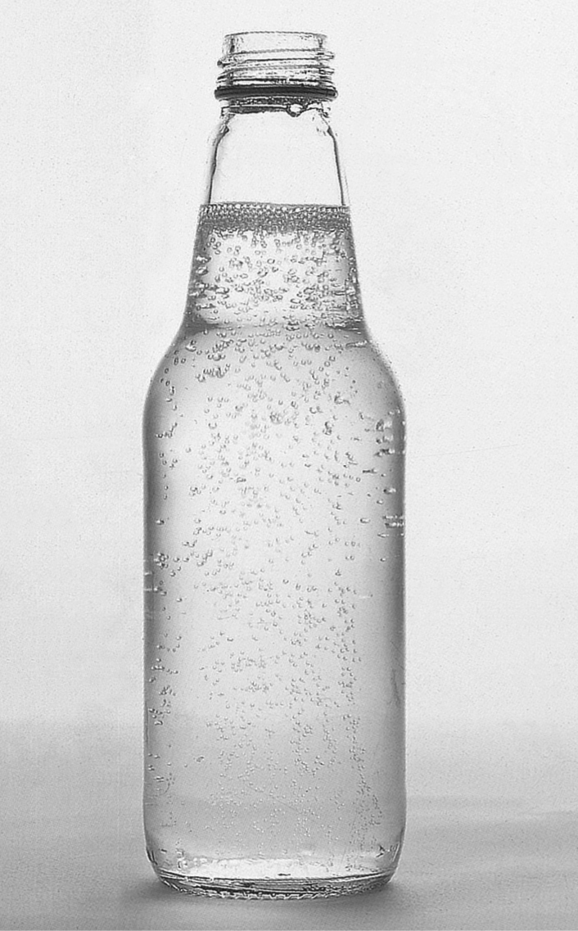

ANDREW KAY PHOTOGRAPHY

When you unscrew a cap from a bottle of soft drink you hear a familiar hissing of gas. This gas and the bubbles clinging to the walls of the bottle are carbon dioxide.

The CO2 in soft drinks is added at the bottling plant in a large sealed chamber called a ‘carbonator’ that has a carbon dioxide atmosphere. Water at a temperature of 0–4°C cascades over a series of plates, and the CO2 dissolves into the water. The pressure of CO2 gas in the chamber is typically four times greater than room air pressure. Under these conditions CO2 is ‘squeezed’ into the water.

A capped bottle or can of soft drink will have CO2 gas in the empty space (headspace) above the liquid at a pressure of 2–3 atmospheres in equilibrium with the CO2 dissolved in the solution. Opening the bottle or can releases the pressure, disturbs the equilibrium and allows excess CO2 to come out of solution.

There are several different methods that can be used to do this experiment.

* Salting,
* Leaving the soda water to go flat naturally, or
* Heating.

We can also test degassing soda water with methyl red indicator. This indicator is pink while the solution still contains dissolved carbon dioxide and yellow once all the carbon dioxide has left. You might like to leave this in combination with one of the other methods.

Your teacher will inform you which method to use –or you may use a variety of methods.

**EQUIPMENT and CHEMICALS**

Unopened bottle of soda water

Electronic Balance

Salt

Either a source of dry heat such as an electric hotplate or a saucepan in which the soda water can be gently warmed

Dry towel

Thermometer

**METHOD 1 - leaving the soda water to go flat**

1. Weigh the soda water bottle before being opened (to take into account the fact that the rate of loss of the carbon dioxide will probably be greatest straight after the bottle is opened).
2. Open the soda water bottle and pour the soda water into a weighed 500mL beaker.
3. Weigh the empty bottle (with the lid!) so that the mass of soda water that is being degassed can be calculated. The sum of the mass of the beaker plus the mass of the added bottle contents is taken as the starting mass of the system before it has lost any gas.
4. Place approximately the same amount of water into another 500mL beaker and weigh this combination. The water in the beaker is to be used as a control, so that the weight loss due to the evaporation of water can be estimated.
5. Leave the two beakers out in the laboratory covered lightly with a piece of paper towel so that flies etc don't fall in.
6. Weigh the beakers at regular intervals over several days. When the mass of the soda water beaker is decreasing by the same amount in a given time as the water beaker, it can be assumed that most of the dissolved carbon dioxide had come out of solution.

**RESULTS**

Mass of the empty beaker (into which the soda water was placed) =

Mass of the full soda water bottle =

Mass of the emptied soda water bottle =

Therefore mass of soda water added =

Therefore, the mass of beaker + degassing soda water initially =

Initial mass of the water + beaker (the control) =

**After 5 days:**

Mass of the soda water beaker =

Mass of the control water beaker =

**After 10 days:**

Initial Mass of the soda water beaker =

Mass of the control water beaker =

**FINAL RESULTS**

Record any observations of the process

Initial mass of soda water =

Final mass of soda water =

Mass of carbon dioxide lost =

Moles of carbon dioxide lost =

Volume of carbon dioxide lost (assume 25oC and 100kPa) =

**METHOD 2 - adding salt to degas the soft drink**

In this method, sodium chloride is added to the soft drink, which causes the carbon dioxide to bubble out of solution. This is probably due to the sodium chloride crystals speeding up the rate of the degassing by providing nuclei for the formation of the carbon dioxide gas bubbles. It may also be the case that carbon dioxide is less soluble in salty water than in tap water.

1. Weigh the soft drink before it is opened (this was to take into account the fact that the rate of loss of the carbon dioxide would probably be greatest straight after the bottle was opened).
2. Open the soda water bottle and pour into a weighed 500mL beaker. Weigh the empty bottle so that the mass of soda water that was degassing can be calculated. The sum of the mass of the beaker plus the mass of the added can contents is taken as the starting mass of the system before it has lost any gas.
3. Add 25 g of sodium chloride slowly to the beaker. The soda water froths up. Weigh the beaker after 10, 20 and 30 minutes (until its mass no longer changed).

**RESULTS**

Mass of the empty beaker (into which the soda water will be placed) =

Mass of the full bottle =

Mass of the emptied bottle =

Therefore, the mass of beaker + degassing soda water initially =

Mass of salt added =

**After 10 minutes:**

Mass of beaker + degassing soda water + salt =

Mass lost =

**After 20 minutes:**

Mass of beaker + degassing soda water + salt =

Mass lost =

**After 30 minutes:**

Mass of beaker + degassing soda water + salt =

(We can conclude that the degassing is complete since the mass is no longer decreasing)

**FINAL RESULTS**

Record any observations of the process

Initial mass of soda water =

Final mass of soda water =

Mass of carbon dioxide lost =

Moles of carbon dioxide lost =

Volume of carbon dioxide lost (assume 25oC and 100kPa) =

**METHOD 3 –using heat to de-gas the soda water**

In this method the soda water is gently heated on a hotplate (or poured into a beaker and heated). This method depends on the reduced solubility of gas as temperature is increased.

1. Weigh the unopened bottle of soda water
2. Slowly remove the cap controlling the release of bubbles so that the soda water does not foam out the top and you lose soda water. If this happens you will need to get another bottle and start all over again! Observe what happens to the release of bubbles when you retighten the cap
3. Reweigh the bottle including the cap
4. Calculate the mass of carbon dioxide lost when the cap was removed
5. Carefully stand the open bottle on a beaker of water on an electric hotplate. Turn the hotplate onto a low or medium heat*. (Check with your teacher as it depends on the type of hotplate used)*  Insert the thermometer. Stirring encourages release of gas bubbles.
6. Heat the soda water bottle to about 38oC (human body temperature). Heat until there appears to be no more bubble formation. (It may take 30-40 minutes ) Note what happens when you put the thermometer into the soda water.
7. Remove the soda water bottle, dry it well with a towel, then reweigh the bottle and its cap.

**RESULTS**

Record any observations of the process

Original weight of soda water + bottle=

Weight of bottle + soda water after heating=

**FINAL RESULTS**

Mass of carbon dioxide lost =

Moles of carbon dioxide lost =

Volume of carbon dioxide lost (assume 25oC and 100kPa) =

**CONCLUSION**

If your class has used different methods in the degassing process, compare these for their

* Ease of performance
* Accuracy
* Effectiveness

**QUESTIONS**

1. Some of the CO2 will remain dissolved in the liquid in the form of carbonic acid. Write an equation for this reaction.
2. The solubility of CO2 is 0.145 g/100 mL at 25ºC and normal atmospheric pressure. Calculate how much CO2 is still dissolved in the soft drink.
3. Compare the class set of results. Are there any significant differences between groups or brands?
4. One manufacturer supplied the following information: a 375 mL bottle contains   
   1.4 L CO2. How does this compare with your results? Suggest possible reasons for differences.

**EXPERIMENT 10**

**Plan and perform a first-hand investigation to measure the ph of identical concentrations of strong and weak acids**

**INTRODUCTION**

The pH of a solution provides a measure of how acidic or basic a solution is. If the pH is known the [H+] can be calculated. Equal concentrations of acids may not have the same pH because the acids may ionise to different extents. A strong acid is one which ionises completely:

HCl(g) + H2O(l) → H3O+(aq) + Cl -(aq)

On the other hand, for a weak acid only some of the molecules ionise:

CH3COOH(aq) + H2O(l)  double_arrow H3O+ (aq) + CH3COO - (aq)

This reaction is an equilibrium one; it does not go to completion. A similar reaction occurs with citric acid which is also a weak acid.

**AIM**

Plan and perform an experiment to compare the pH of equal concentrations of HCl, citric acid and CH3COOH solutions.

**Hints**

***1*** *Equipment: You will need to prepare solutions of accurately known concentration, so using a pipette with a filler and a volumetric flask would provide greater accuracy.*

***2*** *You will need to have an accurate measure of pH so decide whether a pH meter or an indicator would be best. If you decide to use a pH meter review the instructions for use from Experiment 7*

***3*** *Method: Think about the steps you will need to follow. Start with a solution of accurately known concentration. You should compare samples of several known concentrations. Successive dilutions of samples is an appropriate way to obtain samples of different concentrations. For example, you could start with a 0.1 mol/L solution and dilute to 0.01 mol/L. Recall the formula c1v1 = c2v2 to calculate volumes and concentrations for dilutions. Remember to put your method in steps*

***4*** *Results: Draw up a table to record your results.*

**EQUIPMENT**

**CHEMICALS**

**RISK ASSESSMENT**

|  |  |  |
| --- | --- | --- |
| **What is the Risk** | **Why is it a Risk?** | **How will you minimise the risk?** |
|  |  |  |
|  |  |  |
|  |  |  |

**METHOD**

**RESULTS**

Remember to draw up a table.

**CONCLUSION**

**QUESTIONS**

**1** Use the pH to calculate the [H+] for each sample. Include this in your table above.

**2** Compare the pH of the three acids. Which has the lower pH? Which has the highest pH.? Explain the pH of each acid, using relevant equations.

**4** Decide which acid(s) you would classify as strong and which as weak. If you used more than just hydrochloric and acetic (ethanoic) acid list them in order of decreasing strength and explain how you decided this.

**EXPERIMENT 11**

**DETERMINING THE pH OF SALT SOLUTIONS**

**Introduction**

The ionic compounds formed when an acid reacts with a base are salts. Salt solutions can be acidic, basic or neutral depending on how the ions produced when it dissociates in water affect the hydronium ion concentration. For example, ammonium salts such as NH4Cl dissociate to produce NH4+ and Cl+. The NH4+ reacts with water:

NH4+(aq) + H2O(l)  double_arrow NH3(aq) + H3O+(aq)

so producing a solution with a pH < 7.

The pH of salt solutions depends on the parent acid and parent base that have reacted to form the salt. A strong acid and a weak base produce an acidic salt, while a strong base and a weak acid produce a basic salt. A strong acid and a strong base or a weak acid and a weak base give neutral salts.

**Aim**

To select equipment and perform an experiment to determine experimentally the pH of various salt solutions. (You may want to predict the pH before performing the experiment.)

**EQUIPMENT**

* pH meter (review the instructions for use from Experiment 7)
* Small beakers for each solution.
* Spotting plates

**CHEMICALS**

Universal indicator

Approximately 45 mL of each of the following salts should be tested:

0.1 M ammonium chloride

0.1 M potassium nitrate

0.1 M sodium acetate

0.1 M sodium carbonate

0.1 M sodium phosphate

0.1 M ammonium acetate

0.1M ammonium sulfate

0.1M sodium chloride

0.1M sodium hydrogen carbonate

distilled water

**RISK ASSESSMENT**

:

|  |  |  |
| --- | --- | --- |
| What is the Risk | Why is it a Risk? | How will you minimise the risk? |
|  |  |  |
|  |  |  |
|  |  |  |
|  |  |  |
|  |  |  |

**METHOD**

**1** Place a small amount of each salt solution in a separate semi micro test tube or on a spotting plate and test for pH using Universal Indicator.

**2** Use a pH meter to determine the pH and record your results in the results table.

**3** Be sure to rinse the electrode thoroughly between measurements.

**RESULTS**

|  |  |  |  |  |
| --- | --- | --- | --- | --- |
| **NAME OF SALT** | **FORMULA** | **pH USING UNIVERSAL INDICATOR** | **pH METER READING** | **ACIDIC, BASIC OR NEUTRAL** |
|  |  |  |  |  |
|  |  |  |  |  |
|  |  |  |  |  |
|  |  |  |  |  |
|  |  |  |  |  |
|  |  |  |  |  |
|  |  |  |  |  |
|  |  |  |  |  |
|  |  |  |  |  |
|  |  |  |  |  |

**CONCLUSION**

What general conclusion can you make from these results?

**QUESTIONS**

**1** Classify the salts as acidic, basic or neutral.

**2** Write equations to account for the pH of **non-neutral** salts.

**EXPERIMENT 12**

**PREPARATION OF A PRIMARY STANDARD SOLUTION AND USE IT TO MEASURE THE CONCENTRATION OF A SOLUTION OF HYDROCHLORIC ACID**

**INTRODUCTION**

Titrations are a widely used volumetric analytical process for determining the unknown concentration of a substance. They involve measuring the volume of a solution of known concentration that just reacts with a known volume of solution of unknown concentration so there is complete consumption of both reactants. The point of complete consumption is called the equivalence point and can be determined using an indicator.

The known substance is called the standard. The initial or primary standard must be a substance whose concentration can be determined very accurately and consistently. In this experiment a solution of the primary standard, sodium carbonate, will be prepared and then used to determine accurately the concentration of a hydrochloric acid solution.

**Aim**

To prepare a primary standard solution of sodium carbonate and use it to determine the concentration of a hydrochloric acid solution.

**EQUIPMENT**

* electronic balance
* burette
* small beaker
* pipette (25 mL)
* small funnel
* 250 mL volumetric flask
* wash bottle with distilled water
* 2x 250 mL conical flasks
* burette clamp and retort stand
* pipette filler
* stirring rod

**CHEMICALS**

* Approximately 0.1M hydrochloric acid (250mL )
* Approximately 2g Na2CO3
* Approximately 0.1M NaOH
* Suitable indicator (methyl orange, phenolphthalein, bromophenol blue)

**RISK ASSESSMENT**

|  |  |  |
| --- | --- | --- |
| **What is the Risk** | **Why is it a Risk?** | **How will you minimise the risk?** |
|  |  |  |
|  |  |  |
|  |  |  |

**METHOD**

**A Preparing the primary standard**

**1** Calculate the mass of Na2CO3required to make 250 mL of a 0.05M solution

**2** Accurately weigh out into a small beaker a mass approximately equal to that calculated.

**3**  Rinse a 250mL volumetric flask with distilled water and transfer the Na2CO3 to the flask using a small filter funnel.

**4** Use a wash bottle filled with distilled water to carefully wash all the Na2CO3 into the flask. Use 100 – 150mL of distilled water and ensure the Na2CO3is dissolved

**5** Carefully add more distilled water to the volumetric flask until the bottom of the meniscus is level with the mark. Fit the stopper and invert to mix. Make sure the stopper is kept in place.

**B Standardising the hydrochloric acid solution**

**5** Rinse the burette with distilled water and then with the HCl solution to be used and discard the rinsings.

**6** Set up the burette using a retort stand and burette clamp.

**7** Ensure the stopcock is closed and fill the burette with the unknown HCl. Record the starting volume.

**8** Rinse the pipette with the Na2CO3 solution and discard the rinsings.

**9** Fill the pipette with the Na2CO3 solution and place in a clean 250 mL conical flask. This exact volume is known as an aliquot. Add 2–3 drops of methyl orange.

**10** Place the flask under the burette and run the HCl into the flask swirling continuously until the colour changes. This is the end point. Record the end volume.

**11** Calculate the volume of HCl used and record.

**12** Refill the burette if necessary, and repeat steps 8–11 at least twice more until three precise results are obtained.

**C Standardising the sodium hydroxide solution**

Repeat the method in B but place the NaOH solution in the burette and and titrate with the now standard HCl using phenolphthalein as the indicator.

**RESULTS FOR TITRATION OF Na2CO3 AND HCl**

Mass of Na2CO3 used =

|  |  |  |  |  |  |
| --- | --- | --- | --- | --- | --- |
|  | **TRIAL 1** | **TRIAL 2** | **TRIAL 3** | **TRIAL 4** | **TRIAL 5** |
| Volume Na2CO3 used |  |  |  |  |  |
| Initial burette reading |  |  |  |  |  |
| Final burette reading |  |  |  |  |  |
| Volume HCI used |  |  |  |  |  |

**Calculations FOR THE STANDARDISATION OF HCi**

**1** Calculate the concentration of sodium carbonate solution used.

**2** Calculate the number of moles of Na2CO3 used in the titration.

**3** Calculate the average volume of hydrochloric acid used in the titration.

**4** Write a balanced equation for the reaction.

1. Calculate the number of moles of HCl in the sample titrated.
2. Calculate the concentration of the HCl solution.

**RESULTS FOR TITRATION OF HCl AND NaOH**

|  |  |  |  |  |  |
| --- | --- | --- | --- | --- | --- |
|  | **TRIAL 1** | **TRIAL 2** | **TRIAL 3** | **TRIAL 4** | **TRIAL 5** |
| Volume HClused |  |  |  |  |  |
| Initial burette reading |  |  |  |  |  |
| Final burette reading |  |  |  |  |  |
| Volume NaOH used |  |  |  |  |  |

**Calculations FOR THE STANDARDISATION OF NaOH**

**1** Using the known concentration of the HCl, calculate the number of moles of HCl used in the titration.

**2** Calculate the average volume of sodium hydroxide used in the titration.

**3** Write a balanced equation for the reaction.

**4** Calculate the number of moles of NaOH in the sample titrated.

**5** Calculate the concentration of the NaOH solution.

**Questions**

**1** Why must the burette and pipette be thoroughly rinsed with the solution to be used in them?

Compare your answer with other groups in the class. Suggest reasons for any discrepancies.**EXPERIMENT 13 (Dem)**

**Use computer based technologies to measure the equivalence point for the titration of domestic acid and a strong base.**

**INTRODUCTION**

A pH sensor attached to a computer measures pH changes electronically during a titration. The pH changes rapidly at equivalence while a graph of the pH shows different rates of change at different points in the titration. This apparatus can be used to obtain the pH curves for any acid base titration.

Note that

1. A stirrer is used to adequately mix the acid and the base.
2. An indicator is not used
3. The equivalence point can be determined from the computer graph
4. Measurements cannot be continuous. pH is measured initially after the addition of aliquots of 1mL of base at a time but then the pH measure is taken every 0.5 ml as the equivalence point is approached.
5. The solution is placed in a beaker rather than a conical flask to allow the probe to be left in the solution at all times

Background

Commercial vinegar usually contains about 3-5% ethanoic acid (CH3COOH) by mass. The purpose of this experiment is to determine the exact ethanoic acid content of a commercial brand of vinegar. This is achieved by titration with standard approximately 0.1 mol L-' NaOH.

Ethanoic acid reacts with hydroxide ion according to the equation

CH3COOH(aq) + OH-(aq) 🡪 CH3COO-(aq) + H2O(1)



**EQUIPMENT**

* pH probe/data logger
* computer
* magnetic stirrer and stirring bar.

**CHEMICALS**

* 0.1M HCl
* 0.1M NaOH
* Vinegar

1. **TITRATION OF A STRONG ACID AND A STRONG BASE**
2. Transfer 25mL of 0.1M HCl into a clean, dry 100mL beaker.
3. Fill the burette with 0.1M NaOH.
4. Run 1mL of NaOH into the beaker. Measure pH
5. Repeat step 3 until the pH starts to change rapidly
6. Add 0.5 mL at a time measuring the pH after each addition.
7. When the pH change becomes less, then continue adding NaOH in 1 mL aliquots until the pH graph becomes almost horizontal.
8. **TITRATION OF A STRONG BASE AND A DOMESTIC ACID (VINEGAR)**

1. Using a clean dry pipette transfer 10 mL of vinegar into a clean dry 100 mL volumetric flask.

**2.** Fill the flask to the mark with distilled water, stopper the flask and mix the solution by inverting the flask a number of times. This is your 10% vinegar solution which you may wish to transfer to a clean, dry storage bottle in preparation for the next step.

**3.** Use a clean pipette to transfer 25 mL of the 10% vinegar to a clean 100 mL beaker.

**4.** Titrate the vinegar with the 0.1M NaOH solution in exactly the same way as above.

**RESULTS**

Draw a sketch of each of the graphs from the titration above (you may be able to just get a printout of the results.) Determine the equivalence point for each of the acids.

Write the equation for the reaction of ethanoic acid with sodium hydroxide and calculate the number of moles of ethanoic acid in the 25 mL samples of diluted vinegar.

Calculate the concentration of ethanoic acid in the diluted vinegar.

Determine the concentration of ethanoic acid in the undiluted vinegar.

Calculate the mass of ethanoic acid in 1000 mL of undiluted vinegar.

Use the density of the vinegar to calculate the mass of 1000 mL of vinegar.

Determine the mass of ethanoic acid per 100 g of vinegar, that is, the percentage by mass of ethanoic acid in the vinegar.

**CONCLUSION AND DISCUSSION**

**EXPERIMENT 14**

**PREPARATION OF AN ESTER**

**Introduction**

Esters have the general formula R–COOR’, where R and R’ are the same or different alkyl groups. Many of them have pleasant fruity odours and occur widely in nature as perfumes and flavouring agents. Esters account for the distinctive odours of many fruits such as bananas, oranges and strawberries.

They can be synthesised in the laboratory by the reaction between an alcohol and an alkanoic acid; the reaction is called esterification. The low rate of reaction between these compounds means that heat needs to be applied, and the commonly used method is a technique called refluxing. In this method the mixture is boiled and the vapours produced are condensed by means of a condenser and run back into the reacting vessel.

**Aim**

To prepare an ester using reflux.

**EQUIPMENT**

* Hotplate
* Quickfit Liebig condenser
* Quickfit conical flask (150mL)
* Stopper
* Separating funnel
* Boiling chips

**CHEMICALS**

* Approx. 15 mL of 1-pentanol, (or alternative alcohol)
* Approx. 15 mL of glacial acetic acid
* 1 mL of concentrated sulfuric acid (**TEACHER TO DISPENSE**)
* 15 mL of 1 mol/L Na2CO3 solution
* Calcium chloride (anhydrous)

**RISK ASSESSMENT**

:

|  |  |  |
| --- | --- | --- |
| **What is the Risk** | **Why is it a Risk?** | **How will you minimise the risk?** |
|  |  |  |
|  |  |  |
|  |  |  |
|  |  |  |

**METHOD**

**1** Place 10 mL of 1-pentanol, 12 mL of glacial acetic acid and 1 mL of concentrated sulfuric acid in a 150 mL flask.

**2** Add a few boiling chips (do not use marble chips) and assemble the refluxing apparatus as shown in the diagram. Clamp the flask and condenser securely to a retort stand.

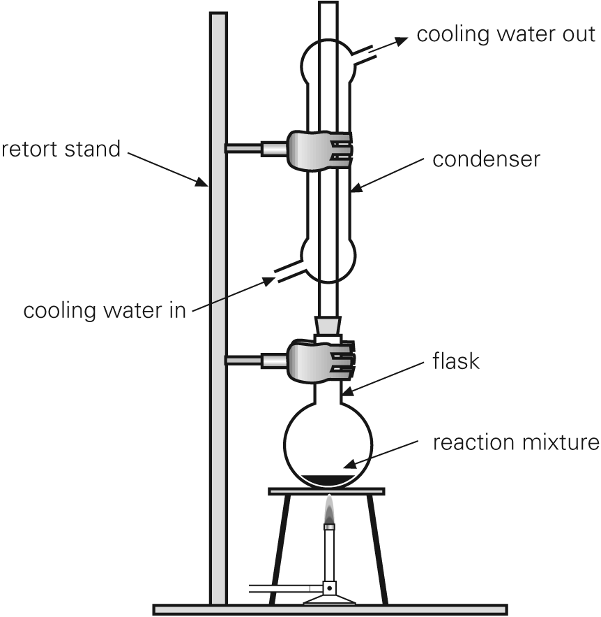

**NB. We do not use a Bunsen flame for this experiment because both the products and reactants are highly flammable**

**3** Connect the tubing to the tap and condenser, and turn on the water so a uniform flow is achieved.

**4** Heat the mixture on the hotplate for approximately 30 minutes and allow to cool for 5 minutes. Turn off the water.

**5** Carefully remove the flask and pour the contents into a separating funnel containing 10–15 mL of water. Stopper the funnel and shake. Allow the layers to separate, drain off and discard the lower aqueous layer.

**6** Add approximately 15 mL of 1 mol/L Na2CO3 solution. Shake, drain and discard the lower layer. The ester should be in the separating funnel.

**7** Carefully smell the ester and describe the smell.

**8** Pour mixture back into flask and add the anhydrous calcium chloride.

**9**  If time permits, distil off the ester.

**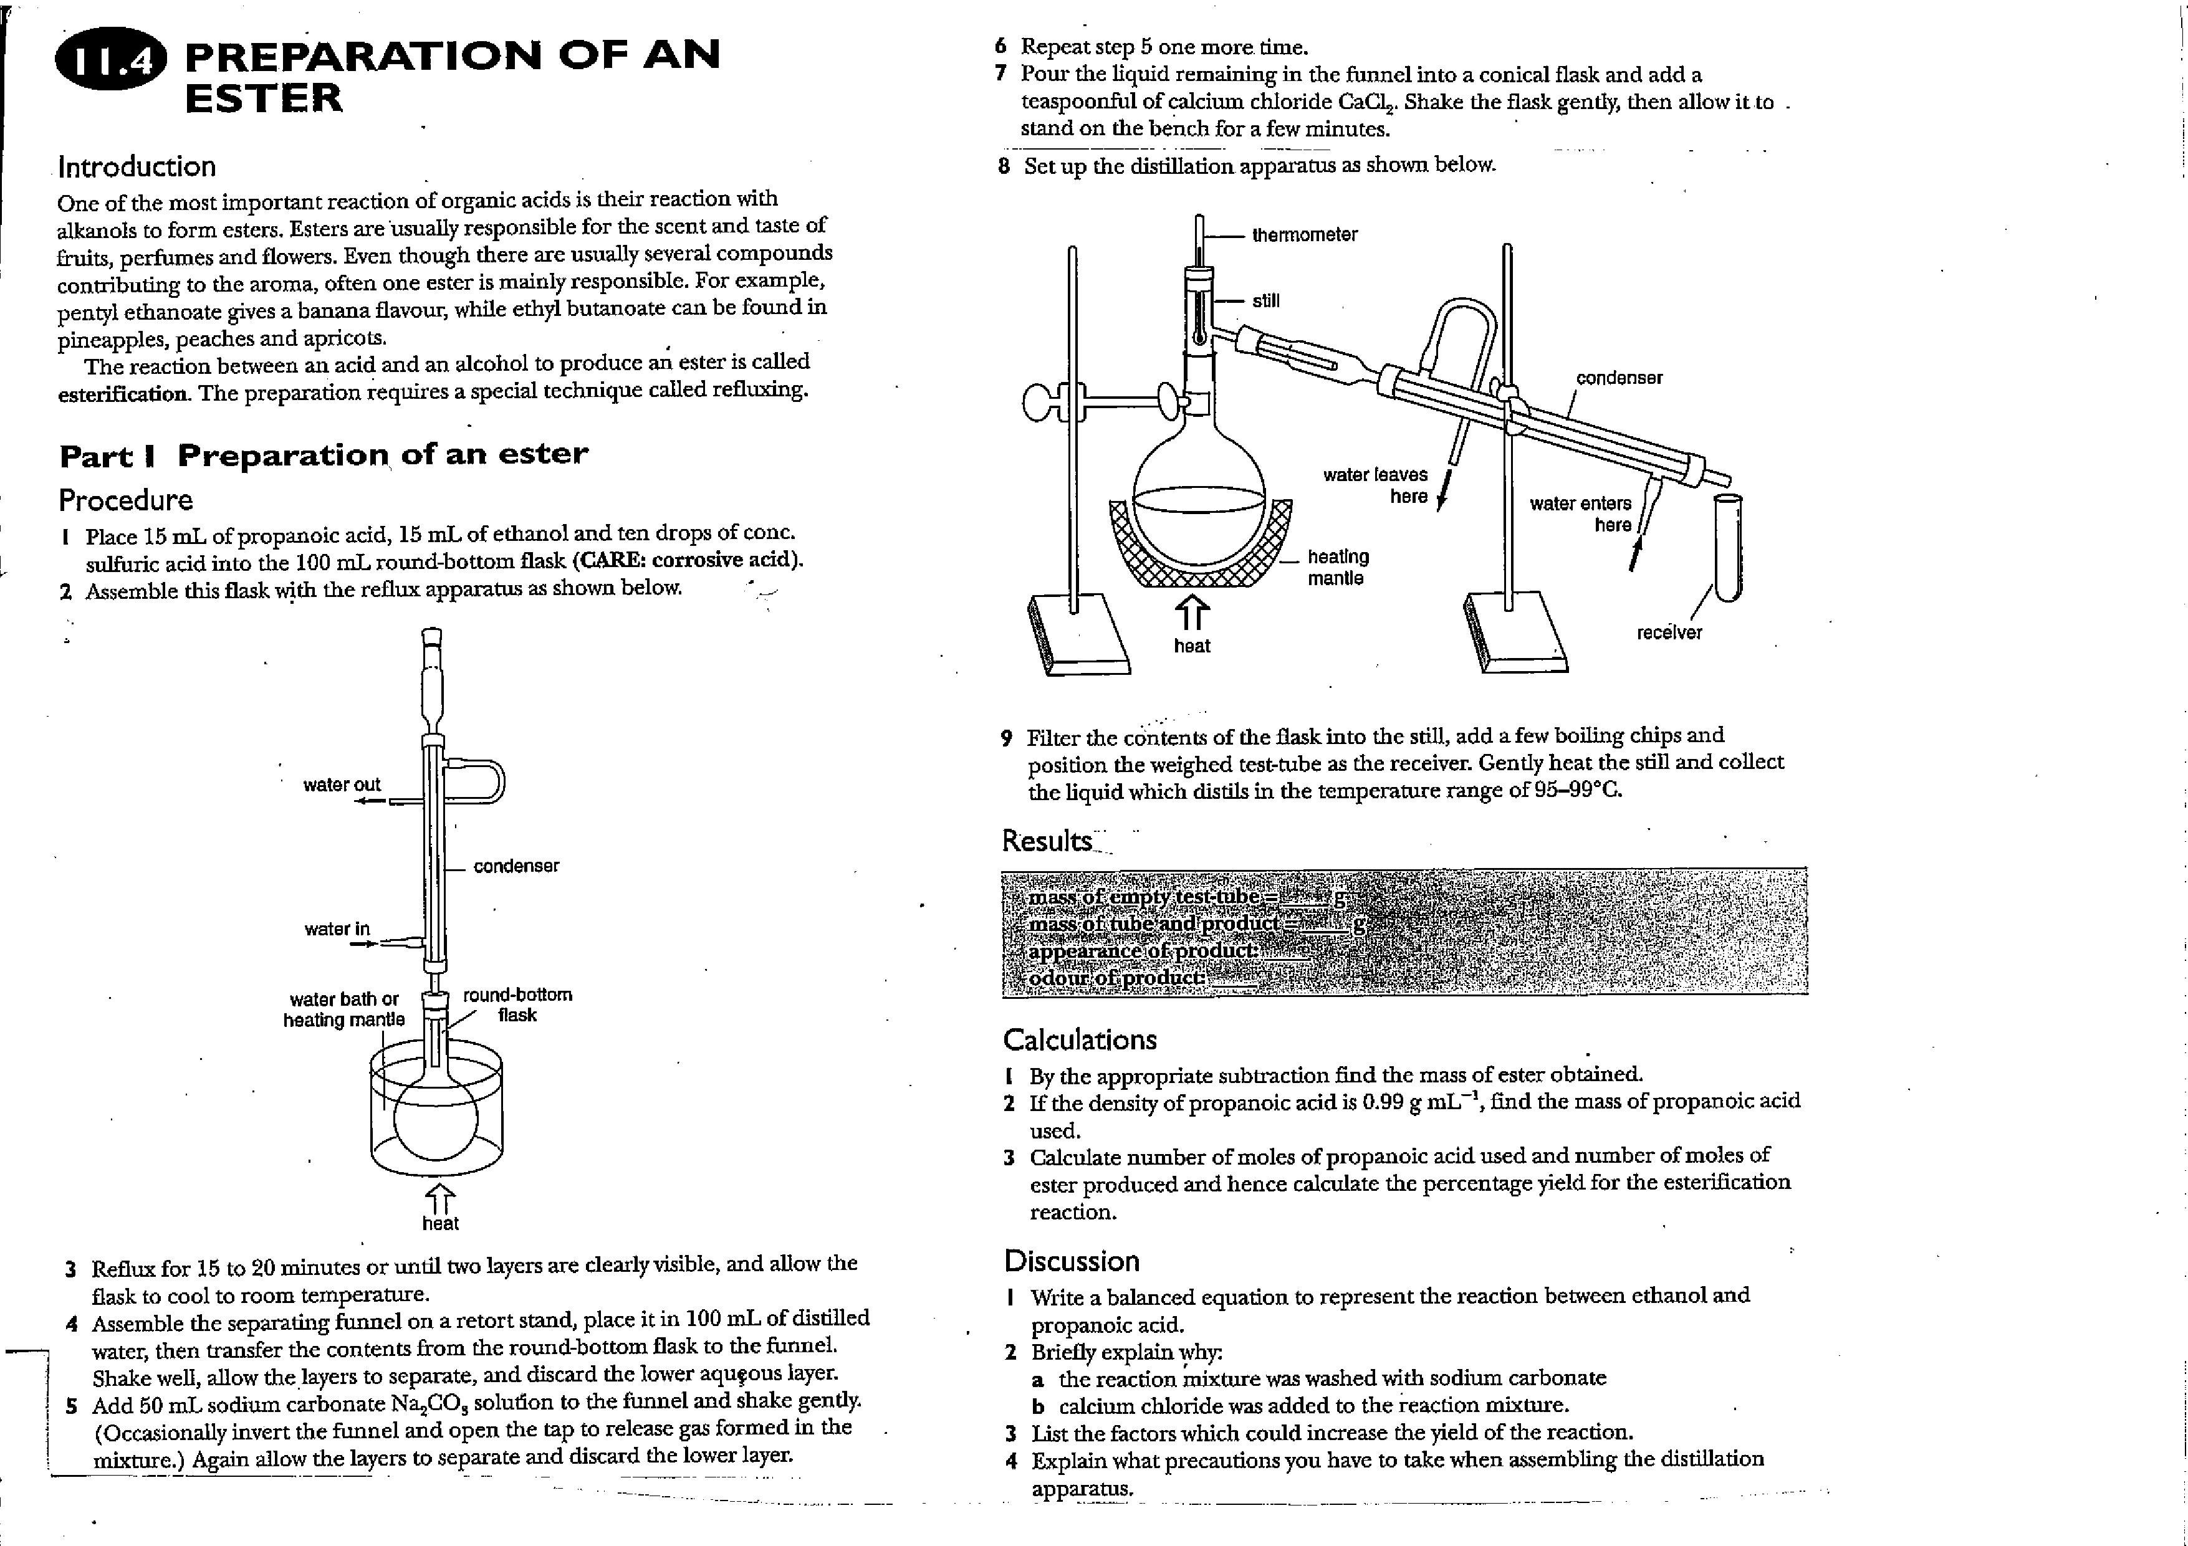**

**OBSERVATIONS AND RESULTS**

**QUESTIONS**

1. Write a balanced equation to represent the reaction between 1-pentanol and ethanoic acid. Use structural formulae.
2. Explain why the reaction mixture was washed firstly with water.

**3** The ester layer obtained in step 5 is slightly acidic. Why is it washed with Na2CO3?

**4** The original reagents react in equimolar quantities, so what is the purpose of adding one reagent in excess?

**5** Which reagent was in excess? Why was an excess of that reagent used rather than an excess of the other one? (Densities of 1-pentanol and glacial acetic acid are 0.81 and 1.04 g/mL respectively.)

**6** If the esterification reaction did not go to completion, the product after step 6 could still be contaminated with reactant. How could you purify it further?